**Praktikum 12A**

* Source Code (sebelum modifikasi)

program **praktikum12A**;

Function **Sum**(x: integer):integer;

Begin

    If x = 1 then

        Sum := 1

    Else

        Sum := x + **Sum**(x - 1);

End;

begin

**writeln**(**sum**(5));

end.

* Output (sebelum modifikasi)

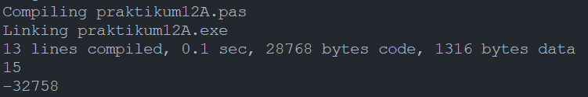

* Source Code (setelah modifikasi)

program **praktikum12A**;

Function **Sum**(x: integer):integer;

Begin

    If x = 0 then

        Sum := 0

    Else if x > 0 then

        Sum := x + **Sum**(x - 1)

    Else

        Sum := x + **Sum**(x + 1);

End;

begin

**writeln**(**sum**(5));

**writeln**(**sum**(-5));

end.

* Output (setelah modifikasi)

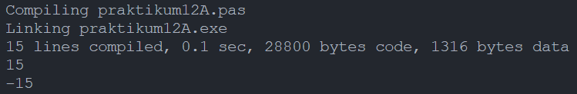

**Praktikum 12B**

* Source Code

Program **praktikum12B**;

uses crt;

var

    menu: byte;

    x, y, hasil: real;

function **faktorial**(x: real):real;

begin

    if x = 1 then

        faktorial := 1

    else

        faktorial := x * **faktorial**(x - 1);

end;

function **penjumlahan**(x, y: real):real;

begin

    penjumlahan := x + y;

end;

function **pengurangan**(x, y: real):real;

begin

    pengurangan := x - y;

end;

function **perkalian**(x, y: real):real;

begin

    perkalian := x * y;

end;

function **pembagian**(x, y: real):real;

begin

    pembagian := x / y;

end;

begin

    hasil := 0;

    menu := 0;

    while(menu <> 6) do begin

        clrscr;

**writeln**('Selamat datang di Kalkulator Sederhana');

**writeln**('Silahkan pilih menu berikut: ');

**writeln**('1. Penjumlahan');

**writeln**('2. Pengurangan');

**writeln**('3. Perkalian');

**writeln**('4. Pembagian');

**writeln**('5. Faktorial');

**writeln**('6. Delete history');

**writeln**('7. Keluar');

**writeln**();

        if hasil <> 0 then **writeln**('History = ', hasil:0:2);

**write**('Pilihan Anda (1-7): '); **readln**(menu);

**writeln**();

        if menu < 5 then begin

            if hasil = 0 then begin

**write**('Masukkan angka pertama: '); **readln**(x);

            end

            else x := hasil;

**write**('Masukkan angka kedua: '); **readln**(y);

        end

        else if menu = 5 then begin

**write**('Masukkan angka: '); **readln**(x);

        end;

        case menu of

            1: hasil := **penjumlahan**(x, y);

            2: hasil := **pengurangan**(x, y);

            3: hasil := **perkalian**(x, y);

            4: hasil := **pembagian**(x, y);

            5: hasil := **faktorial**(x);

            6: hasil := 0;

            7: exit;

            else exit;

        end;

    end;

end.

* Output

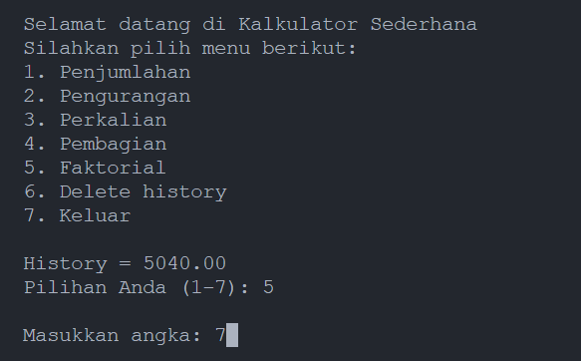

**Praktikum 12C**

* Source Code (sebelum modifikasi)

program **praktikum12C_sebelumModifikasi**;

PROCEDURE **TULIS_1**(banyak : integer; kata : string);

    begin

        if banyak > 1 then **TULIS_1**(banyak-1,kata);

**writeln**(kata, banyak);

    end;

begin

**TULIS_1**(5, 'Cetakan ke ');

end.

* Output (sebelum modifikasi)

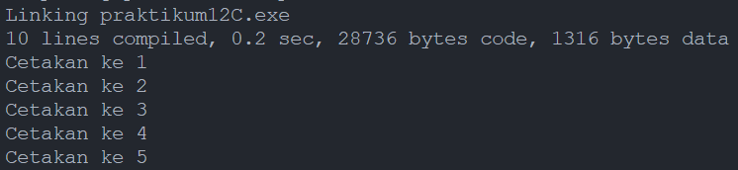

* Source Code (setelah modifikasi)

program **praktikum12C_setelahModifikasi**;

PROCEDURE **TULIS_1**(banyak : integer; kata : string);

    begin

**writeln**(kata, banyak);

        if banyak > 1 then **TULIS_1**(banyak-1,kata);

    end;

begin

**TULIS_1**(5, 'Cetakan ke ');

end.

* Output

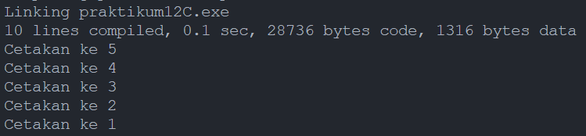

**Praktikum 12D**

* Source Code (function)

program **penugasan12D_function**;

var

    x, i: integer;

function **fib**(n: integer): integer;

    begin

        if(n = 1) then

            fib := 1

        else if (n = 2) then

            fib := 1

        else

            fib := **fib**(n - 1) + **fib**(n - 2);

    end;

begin

**writeln**('deret fibonacci');

**write**('input value : ');

**readln**(x);

    writeln;

    for i := 1 to x do **write**(**fib**(i),' ');

    readln;

end.

* Output (function)

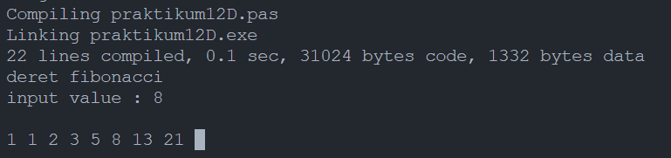

* Source Code (procedure)

program **praktikum12D_procedure**;

procedure **pib**(n:integer; var hsl :integer);

    var f1, f2: integer;

    begin

        if(n = 1) or (n = 2) then

            hsl := 1

        else begin

**pib**(n - 1, f1);

**pib**(n - 2, f2);

            hsl := f1 + f2;

        end;

    end;

var

    x, i: integer;

    hsl: integer;

begin

**writeln**('Barisan Bilangan Fibonacci');

**write**('Jumlah bilangan Fibonnaci yang ingin ditampilkan : ');

**readln**(x); writeln;

    for i := 1 to x do begin

**pib**(i, hsl);

**write**(hsl, ' ');

    end;

    readln;

End.

* Output (procedure)

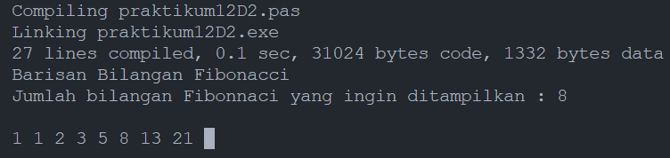

* Perbedaan

Workflow dengan menggunakan function :

fib(8) = fib(7) + fib(6)

fib(7) = fib(6) + fib(5)

fib(6) = fib(5) + fib(4)

fib(5) = fib(4) + fib(3)

fib(4) = fib(3) + fib(2)

fib(3) = fib(2) + fib(1)

fib(2) = 1

fib(1) = 1

fib(3) = 1 + 1 = 2

fib(4) = 2 + 1 = 3

fib(5) = 3 + 2 = 5

fib(6) = 5 + 3 = 8

fib(7) = 8 + 5 = 13

fib(8) = 13 + 8 = 21

Sedangkan, untuk workflow dengan procedure :

for i = 1 to 8

i = 1 -> pib(1, 0) -> hsl = 1

i = 2 -> pib(2, 1) -> hsl = 1

i = 3 -> pib(3, 1)

-> pib(2, 0)

hsl = 1

-> pib(1, 0)

hsl = 1

hsl = 1 + 1 = 2

i = 4 -> pib(4, 2)

-> pib(3, 0)

-> pib(2,0) -> hsl = 1

-> pib(1,0) -> hsl = 1

hsl = 2

-> pib(2, 0) -> hsl = 1

hsl = 3

i = 5 -> pib(5, 3)

-> pib(4, 0)

-> pib(3, 0) -> hsl = 2

-> pib(2, 0) -> hsl = 1

hsl = 2 + 1 = 3

-> pib(3, 0) -> hsl = 2

hsl = 3 + 2 = 5

i = 6 -> pib(6, 5)

-> pib(5, 0)

-> pib(4, 0) -> hsl = 3

-> pib(3, 0) -> hsl = 2

hsl = 5

-> pib(4, 0) -> hsl = 3

hsl = 8

i = 7 -> pib(7, 8)

-> pib(6, 0)

-> pib(5, 0) -> hsl = 5

-> pib(4, 0) -> hsl = 3

hsl = 5 + 3 = 8

-> pib(5, 0) -> hsl = 5

hsl = 8 + 5 = 13

i = 8 -> pib(8, 13)

-> pib(7, 0)

-> pib(6, 0) -> hsl = 8

-> pib(5, 0) -> hsl = 5

hsl = 13

-> pib(6, 0) -> hsl = 8

hsl = 21